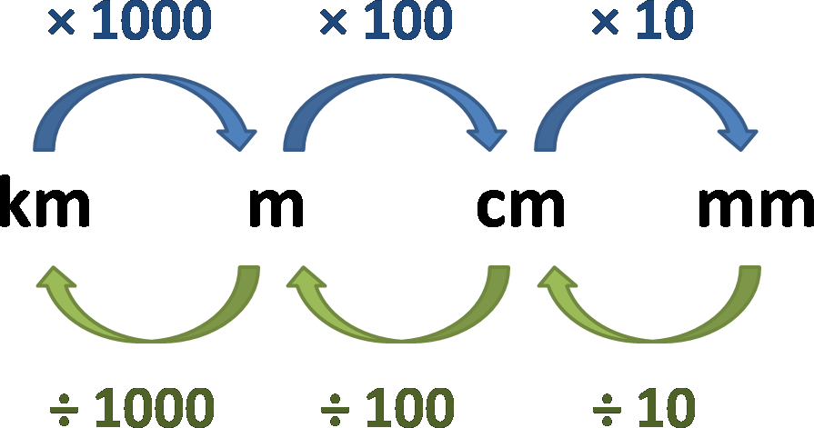

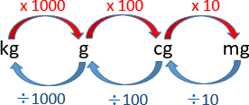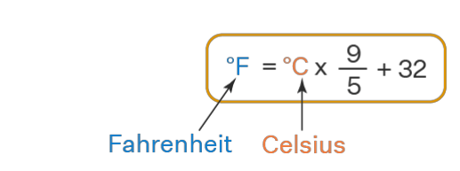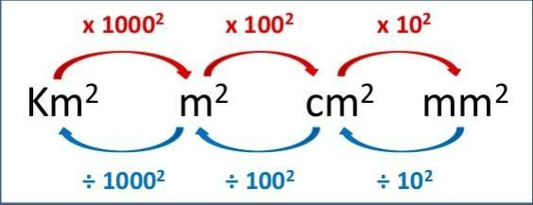

**. 101300 N/M2 =101300 Pascal = 1013 Milli Bar = 1 atm = 760 mmhg**

. 1 Bar=1000millibar = 105 Pascal = 105 N/m2

𝐐𝐭𝐡 = 𝐦 𝐜 ∆𝐭

Qth

m C ∆𝐭

F = P × A. F P A

Ptotal = Pa + Pliquid = Pa + ρ g h

Pliquid = ρ g h

Pliquid

ρ g h

1 Bar= 1 atm = 105 Pascal = 105 N/m2

**Devices**

**Barometer: used to measure atmospheric pressure**

**pH meter: used to measure of how acidic/basic water is.**

**Joule calorimeter: used to determine the specific heat of water.**

**Moisture meter: to detect moisture content in soil.**

**hygrometer: to measure the humidity, or amount of water vapor in the air.**

**Gas Chromatography: It is used to analyze volatile organic compounds such as benzene, and formaldehyde**

**UV spectroscopy :Used to measure oxides of nitrogen and ozone in the air.**